Insert your name, centre number and candidate number into the header above.
Save this evidence document as evidence_ followed by your centre number_ candidate number. For example: evidence_ zz999_9999.doc
Screenshots or program listings must be copied into appropriate cells in the following tables.
Examiners must be able to read the contents including any screenshots without the use of a magnifying glass. Answers that are not readable or missing will not be awarded any marks.
Save this evidence document at regular intervals, for example, every 10 minutes.
Question 1
Part 1(a)
global NumberWords, WordArray
NumberWords = -1
WordArray = []
def ReadWords(file):
global NumberWords, WordArray
try:
with open(file, "r", encoding = "utf-8") as f:
for line in f:
NumberWords += 1
WordArray.append(line.strip())
Play()
except FileNotFoundError:
print("File does not exist!")

Part 1(b)
def main():
f = input("Enter file easy, medium, or hard: ")
if f.lower() in ["easy", "medium", "hard"]: ReadWords(f"{f[0].upper() + f[1:].lower()}.txt")

if __name__ == "__main__":
main()

Part 1(c)(i)
def Play():
global NumberWords, WordArray
print(WordArray[0])
cnt = 0
while True:
ans = input("Enter the word: ")
if ans.lower() == "no":
break
elif ans in WordArray:
cnt += 1
for i in range(len(WordArray)):
if WordArray[i] == ans.lower():
WordArray[i] = None
print("Answer correct!")
else:
print("Answer incorrect!")

Part 1(c)(ii)
def Play():
global NumberWords, WordArray
print(WordArray[0])
cnt = 0
while True:
ans = input("Enter the word: ")
if ans.lower() == "no":
break
elif ans in WordArray:
cnt += 1
for i in range(len(WordArray)):
if WordArray[i] == ans.lower():
WordArray[i] = None
print("Answer correct!")
else:
print("Answer incorrect!")
print(f"You got {cnt / len(WordArray) * 100:.2f}% of answers correct!")
if cnt != len(WordArray):
print("Here are words you didn't answer:")
for i in range(len(WordArray)):
if WordArray[i] != None:
print(WordArray[i])

Part 1(d)(i)
def ReadWords(file):
global NumberWords, WordArray
try:
with open(file, "r", encoding = "utf-8") as f:
for line in f:
NumberWords += 1
WordArray.append(line.strip())
Play()
except FileNotFoundError:
print("File does not exist!")

Part 1(d)(ii)
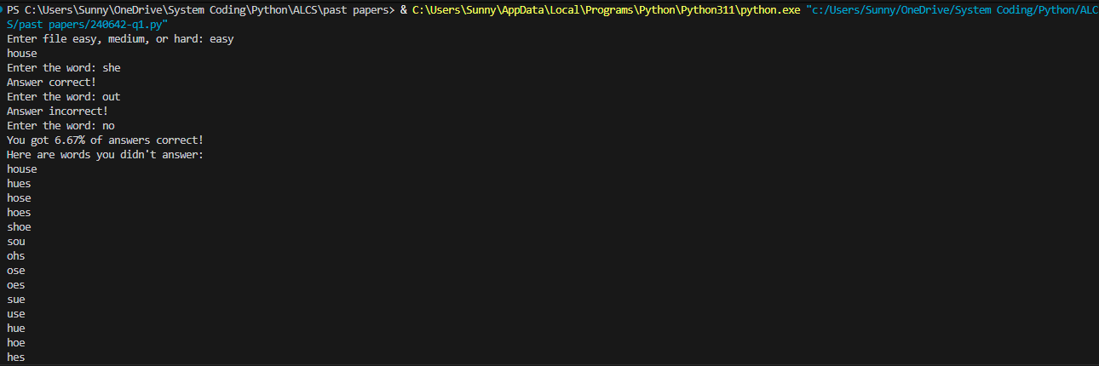

Part 1(d)(iii)
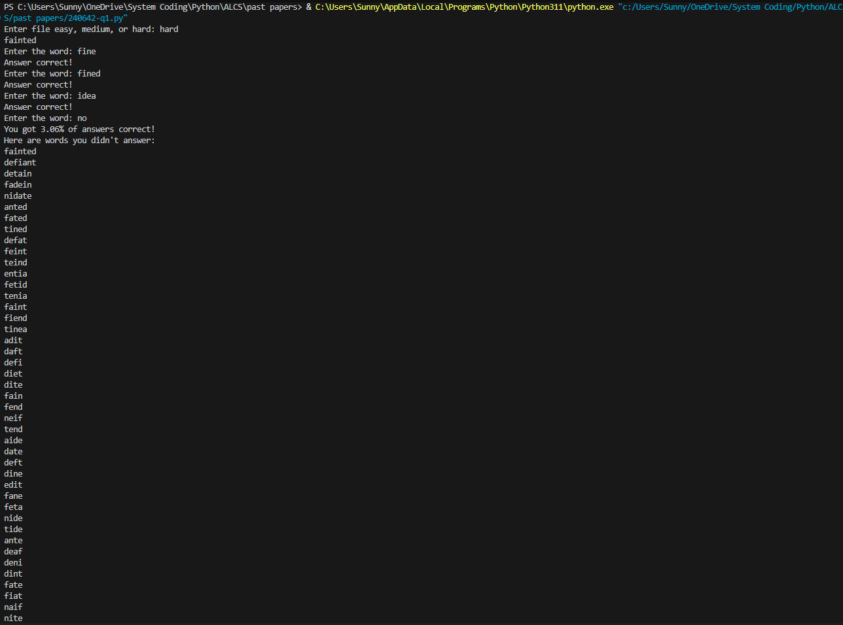
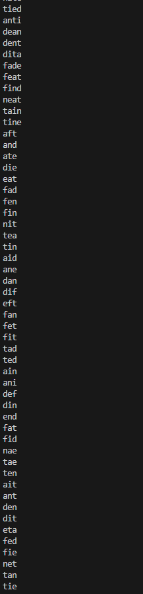

Question 2
Part 2(a)(i)
class Node:
def __init__(self, d):
self.__LeftPointer = -1 #integer
self.__Data = d #integer
self.__RightPointer = -1 #integer

Part 2(a)(ii)
def GetLeft(self):
return self.__LeftPointer
def GetRight(self):
return self.__RightPointer
def GetData(self):
return self.__Data

Part 2(a)(iii)
def SetLeft(self, l):
self.__LeftPointer = l
def SetRight(self, r):
self.__RightPointer = r
def SetData(self, d):
self.__Data = d

Part 2(b)(i)
class TreeClass:
def __init__(self):
self.__Tree = [Node(-1)] * 20 #array of type Nodes
self.__FirstNode = -1 #integer
self.__NumberNodes = 0 #integer

Part 2(b)(ii)
def InsertNode(self, NewNode):
if self.__NumberNodes == 0:
self.__Tree[self.__NumberNodes] = NewNode
self.__FirstNode = 0
self.__NumberNodes += 1
else:
self.__Tree[self.__NumberNodes] = NewNode
idx = self.__FirstNode
while True:
if self.__Tree[idx].GetData() > NewNode.GetData():
if self.__Tree[idx].GetLeft() == -1:
self.__Tree[idx].SetLeft(self.__NumberNodes)
break
else:
idx = self.__Tree[idx].GetLeft()
elif self.__Tree[idx].GetData() < NewNode.GetData():
if self.__Tree[idx].GetRight() == -1:
self.__Tree[idx].SetRight(self.__NumberNodes)
break
else:
idx = self.__Tree[idx].GetRight()
self.__NumberNodes += 1

Part 2(b)(iii)
def OutputTree(self):
if self.__NumberNodes == 0:
print("No nodes")
else:
for i in range(self.__NumberNodes):
print(f"{self.__Tree[i].GetLeft()} {self.__Tree[i].GetData()} {self.__Tree[i].GetRight()}")

Part 2(c)(i)
def main():
TheTree = TreeClass()

if __name__ == "__main__":
main()

Part 2(c)(ii)
def main():
TheTree = TreeClass()
TheTree.InsertNode(Node(10))
TheTree.InsertNode(Node(11))
TheTree.InsertNode(Node(5))
TheTree.InsertNode(Node(1))
TheTree.InsertNode(Node(20))
TheTree.InsertNode(Node(7))
TheTree.InsertNode(Node(15))
TheTree.OutputTree()

if __name__ == "__main__":
main()

Part 2(c)(iii)
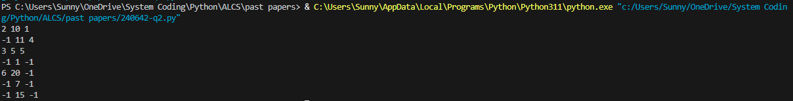

Question 3
Part 3(a)
NumberArray = [100, 85, 644, 22, 15, 8, 1]

Part 3(b)(i)
def RecursiveInsertion(IntegerArray, NumberElements):
if NumberElements <= 1:
return IntegerArray
RecursiveInsertion(IntegerArray, NumberElements - 1)
LastItem = IntegerArray[NumberElements - 1]
CheckItem = NumberElements - 2
LoopAgain = True
if CheckItem < 0:
LoopAgain = False
elif IntegerArray[CheckItem] < LastItem:
LoopAgain = False
while LoopAgain:
IntegerArray[CheckItem + 1] = IntegerArray[CheckItem]
CheckItem -= 1
if CheckItem < 0:
LoopAgain = False
elif IntegerArray[CheckItem] <= LastItem:
LoopAgain = False
IntegerArray[CheckItem + 1] = LastItem
return IntegerArray

Part 3(b)(ii)
def main():
NumberArray = [100, 85, 644, 22, 15, 8, 1]
print("Recursive")
#print(len(NumberArray))
res = RecursiveInsertion(NumberArray, len(NumberArray))
for i in range(len(res)):
print(res[i], end = " ")

if __name__ == "__main__":
main()

Part 3(b)(iii)

Part 3(c)(i)
def IterativeInsertion(IntegerArray):
sorted = 0
idx = 0
while sorted < len(IntegerArray):
min = IntegerArray[sorted]
for i in range(sorted, len(IntegerArray)):
if IntegerArray[i] < min:
idx = i
min = IntegerArray[i]
j = idx
while j > sorted:
IntegerArray[j], IntegerArray[j - 1] = IntegerArray[j - 1], IntegerArray[j]
j -= 1
sorted += 1
return IntegerArray

Part 3(c)(ii)
def main():
NumberArray = [100, 85, 644, 22, 15, 8, 1]
print("Iterative")
res = IterativeInsertion(NumberArray)
for i in range(len(res)):
print(res[i], end = " ")

if __name__ == "__main__":
main()

Part 3(c)(iii)

Part 3(d)(i)
def BinarySearch(IntegerArray, First, Last, ToFind):
if Last < First:
return -1
elif IntegerArray[(First + Last) // 2] == ToFind:
return (First + Last + 1) // 2
elif IntegerArray[(First + Last) // 2] > ToFind:
return BinarySearch(IntegerArray, First, (First + Last - 1) // 2, ToFind)
else:
return BinarySearch(IntegerArray, (First + Last + 1) // 2, Last, ToFind)

Part 3(d)(ii)
def main():
NumberArray = [100, 85, 644, 22, 15, 8, 1]
print("Iterative")
res = IterativeInsertion(NumberArray)
for i in range(len(res)):
print(res[i], end = " ")
idx = BinarySearch(NumberArray, 0, len(NumberArray) - 1, 644)
if idx == -1:
print("\nNot found.")
else:
print(f"\n{idx}")

if __name__ == "__main__":
main()

Part 3(d)(iii)

